Name & ID: Abraham Kuriakose- 550217239
Please provide comprehensive answers to each question.

INFO5992 Understanding IT Innovations
Tutorial 10 Worksheet

Deaths by J-Curve

How can a start-up fail?
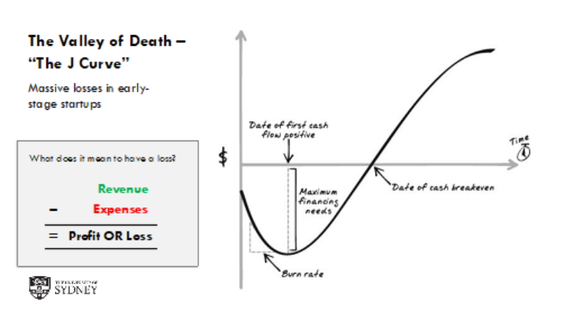

Recall this figure from the lecture. Every start-up goes through the valley of death in the J Curve. Most start-ups fail in the valley of death. Today, we will examine such an example and try to unravel why they failed in the Valley of Death.

Question 1: Based on the pre-reading(s), list and explain three common reasons why startups fail.
Answer:
1. Running Out of Cash / Poor Financial Management
- Startups burn through capital faster than anticipated during the valley of death
- Inability to secure additional funding before cash runs out
- Underestimating how long it takes to achieve product-market fit and generate revenue
2. No Market Need / Product-Market Fit Issues
- Building a product that solves a problem nobody has or nobody is willing to pay for
- Failing to validate customer demand before investing heavily in development
- Misunderstanding the target market's actual needs
3. Wrong Team / Founder Issues
- Lack of necessary skills or experience in the founding team
- Founder conflicts and poor team dynamics
- Inability to pivot or adapt when initial assumptions prove wrong

Question 2: Pick a recent startup failure (or use a scenario provided in class) and specify which mistake(s) did it make that led to its failure?

Answer: Quibi Startup Failure Analysis
Company Overview: Quibi was a short-form streaming platform founded by Jeffrey Katzenberg and Meg Whitman, designed to deliver 10-minute episodes of premium content specifically for mobile viewing. Despite raising $1.75 billion in funding, it failed spectacularly.
Key Mistakes That Led to Failure:
1. No Market Need / Misreading Consumer Demand
- Quibi assumed people wanted premium short-form content on mobile exclusively
- The market already had free short-form content (YouTube, TikTok, Instagram)
- Consumers weren't willing to pay $5-8/month for something they could get free elsewhere
- They solved a problem that didn't exist for most users
2. Poor Timing and Inability to Pivot
- Launched in April 2020, right during COVID-19 lockdowns
- Their value proposition was "watch during your commute" - but nobody was commuting
- Failed to quickly pivot their strategy or allow viewing on TVs/larger screens
- Stuck to their original vision despite dramatically changed circumstances
3. Wrong Product Features / Poor User Experience
- No screenshot capability (restricted by DRM)
- Couldn't cast to TV initially (later added, but too late)
- No social sharing features - couldn't compete with viral nature of TikTok
- Content wasn't compelling enough to justify the subscription cost
Connection to the J-Curve Valley of Death: Quibi had massive funding, so they didn't fail due to lack of capital. Instead, they failed because they couldn't achieve product-market fit during the critical early phase. They burned through capital rapidly without validating that customers actually wanted their product, and when user growth stalled immediately after launch, they couldn't recover.

